METHODOLOGY - (EXPERIMENTAL CONCEPTUAL)

CHAPTER 3. METHODOLOGY

- Research Framework

- Hypotheses

- Population

- Experiment Setup

- Procedure

- Instruments

- Data Analysis

- Summary

- Research Framework

Research has revealed that a pleasurable user experience can create loyalty and determine the success of a product or technology (Garrett, 2006). Pleasure is generated by a positive user experience, and as humans want to move away from pain and toward pleasure, this is a natural tendency (Jordan, 1999). The purpose of this research is to find how novelty in web design affects preference and user experience. In this study the author seek to investigate the effects of parallax scrolling on subjective user experience.

- Hypotheses

This study seeks to investigate the effects of parallax scrolling on web design. Group 1 contains the website utilizing parallax scrolling and group 2 contains the website with no parallax scrolling. The following hypotheses will be tested:

HO1: There are no significant differences in perceived usability between the two groups
HA1: There are significant differences in perceived usability between the two groups

HO2: There are no significant differences in perceived enjoyment between the two groups

HA2: There are significant differences in perceived enjoyment between the two groups

HO3: There are no significant differences in the fun user experience between the two
groups
HA3: There are significant differences in the fun user experience between the two groups

HO4: There are no significant differences in user satisfaction between the two groups
HA4: There are significant differences in user satisfaction between the two groups

HO5: There are no significant differences in visual appeal between the two groups
HA5: There are significant differences in visual appeal between the two groups

HO6: There are no significant differences in overall user experience between the two
groups
HA6: There are significant differences in overall user experience between the two groups

HO7: There are no significant differences in user preference between the two groups
HA7: There are significant differences in user preference between the two groups

- Population

Participants for this study were recruited from Stewart Centre at Purdue University. The intercept method was used to recruit students as they walked through the hallway of Stewart Centre. Participants who opted to take part in the research experiment were offered a chance to enter in a raffle for three gift cards of $20.00. A sample size of 86 participants was used in the research experiment. This was consistent with previous research conducted in the field (Dudek, & Brown, 2006; Lindgaard, Fernandes, Hung & Chen, 2012; Sauer & Sonderegger, 2011). In keeping with other research (Al-Shamaileh & Sutcliffe, 2012; Lindgaard, Fernandes, Dudek, & Brown, 2006), a between group design was employed and participants were randomly assigned to one of two groups (43 in each condition).

- Experiment Setup

The objective of this research experiment was to investigate how the independent variable (scrolling technique) affected the dependent variables (satisfaction, usability, enjoyment, visual appeal, and fun). These five variables have been shown to contribute to the overall user experience (Hassenzahl & Tracinski, 2006; Norman, 2003). The researcher decided to utilize a between-subject research design where scrolling technique was manipulated at two levels. An advantage of the between-subject design is that it prevents any carry over effects such as fatigue, boredom or practice that can affect and skew the results of the study. Since each participant was exposed to only one of two treatments, participants’ decisions were not affected by such extraneous factors (Gravetter & Forzano, 2011).
The control group in the experiment was assigned to work with the website not using parallax scrolling while the treatment group used the website employing the parallax scrolling technique.

- Procedure

The author constructed two similar hotel websites for this study experiment (see Figure 3.1), with the exception of the scrolling mechanism. In order to test the websites in a real-world environment, both websites were uploaded unto a server over the internet where participants accessed them. Two laptop computers with internet access were set up on a table in the lobby at the Stewart Centre to conduct the experiment.


Students were intercepted as they passed by and asked to participate in the experiment, which lasted no more than five minutes. Individuals who opted to participate in the experiment were randomly assigned to one of two experimental conditions.
Each condition's participants were shown a single version of the website.
Participants in condition 1 were presented with the website version utilizing the parallax scrolling effect while participants in group 2 interacted with the website without parallax scrolling. Before the experiment began, each participant received a page with instructions to help them through the experiment. Upon reading the instructions, participants navigated to a web address that was provided to them on the computer by directly clicking on the link or entering the provided URL
Following task completion, participants responded to a fifteen-item post-test survey to gauge their general website experience. All survey items were measured on a 6-point Likert scale ranging from “strongly disagree” (1) to “strongly agree” (6). You can find this survey instrument in Appendix C.

- Instruments

The validation of the research instrument is an integral part of any research project because it accounts for the reliability of the results. If the tools utilized in a study are not validated, the results of the study cannot be trusted. “Instruments with validation enable researchers to measure same research constructs in a consistent manner, leading to in improved measurements of the dependent and independent variables” (Straub, 1989, p. The researcher referenced two validation guidelines in the validation of the tool of research utilized in this investigation. Face validity and content validity were two of these. The simplest type of validation is facing validity, which can be ascertained by examining the instrument with respect to clarity and organization and deciding whether it looks valid 2009 saw it. Crow, French, and the Lord. This decision was taken by the researcher before the survey's gadget was distributed. Content validity assesses if the inquiries contained in the instruments are typical of the field under investigation (Li & Yeh, 2010). Using this as a reference, the researcher decided to use elements from previous, confirmed studies in the following configurations: usability (Flavián, Guinalíu, & Gurrea, 2006), enjoyment (Cyr, Head, & Ivanov, 2006; Van der Heijden, 2004), fun (Cyr, Head, & Ivanov, 2006; Van der Heijden, 2004), satisfaction (Cyr, Bonanni, Bowes, & Ilsever, 2005; Sauer & both aesthetic appeal (Cyr, Head, & Ivanov, 2006; Li, & Yeh, 2010) and Sonderegger (2011).

- Data Analysis

The Statistical Package for Social Sciences (SPSS) software was used to analyse the data. Because the experiment involves study participants answering Likert scale items on a questionnaire, ranked data rather than numerical data were analysed. In order to adequately carry out this analysis, the Mann-Whitney non-parametric test was used to analysis the data. The Mann-Whitney test is the non-parametric equivalent of the independent samples t-test and was used to test the differences between the two experimental groups (Field & Hole, 2003). The Mann-Whitney test was used because Likert scale items contain ordinal data rather than interval or ratio. In such instances parametric test methods cannot be used because of their strict assumptions.

- Demographics of participants

The following section describes the demographics of the participants in this research. A total of eighty-six people took part in the study and finished the questionnaire. The experiment was conducted at the Stewart Centre at Purdue University which is a central location, thus providing an equal opportunity for students

from every major to take part in the study project. The College of Engineering and Liberal Arts accounted for 20.9% and 18.6% of the overall sample, respectively, with the bulk of participants. Of the remaining participants 12.7% were from the College of Health and Human Sciences, followed by the College of Science (11.6 %), College of Agriculture (8.1 %), College of Technology (8.1 %), College of Pharmacy (5.8 %), College of Education (5.8 %), Krannert School of Management (4.6 %), and the last three individuals were not affiliated with any department at the school. Figure 4.1 provides a thorough analysis of these data.

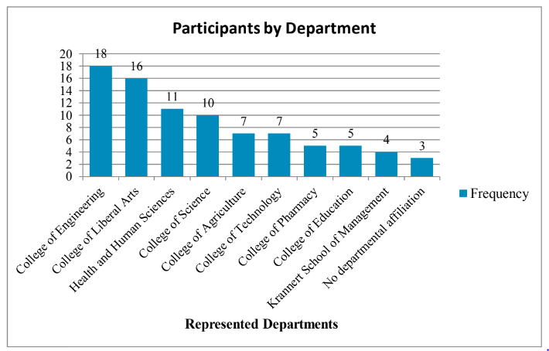

- Analysis and hypotheses testing
It was believed that user preference and experience would be impacted by parallax scrolling in web design. Consequently, seven conjectures were developed to bolster this theory. This section contains these theories as well as the empirical analysis that supports or refutes them. The five dependent variables (usability, enjoyment, fun, satisfaction, and visual appeal) were compared between the two groups' participant replies using the Mann-Whitney test to determine any differences.

- Usability

It was hypothesized that parallax scrolling would positively influence the perceived usability of the website. This was measured by the first three items of the survey instrument which can be found in table 4.1 below. The Mann-Whitney test failed to return any significant differences in participants’ ratings with regard to these items.

Items from survey instrument measuring website usability
Q1. This website is simple to use, even when using it for the first time
Q2. Downloading pages from this website is quick
Q3. The structure and contents of this website are easy to understand

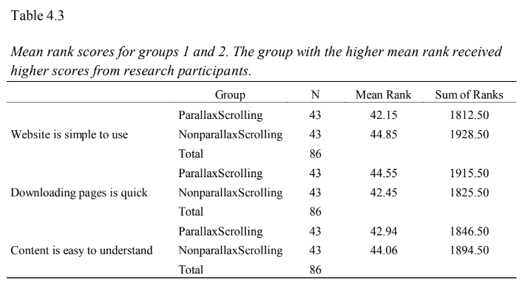

- Enjoyment

The results returned from the Mann-Whitney test indicated that the two website versions did not differ significantly with respect to overall user enjoyment. Table 4.3 lists the items from the survey measuring this variable. Results of the Mann-Whitney test statistic with respect to Q1, Q2 and Q3. Website is simple to use downloading pages is quick content is easy to understand.
Mann-Whitney U 866.500 879.500 900.500 Wilcoxon W 1812.500 1825.500 1846.500 Z -.550 -.418 -
.230 Asymp. Sig. (2-tailed) .583 .676 .818

a. Grouping variable: Group
Items measuring website enjoyment
Q4. This website is pleasant to use
Q5. I liked using this website
Q6. I found using this website to be enjoyable

- Satisfaction

Items measuring website satisfaction
Q10. I am satisfied with my performance on this website
Q11. This website satisfies my particular needs well
Q12. The experience that I have had with this website has been satisfactory

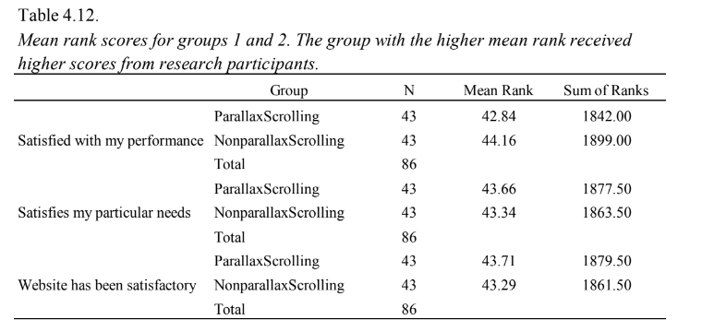

- Visual appeal

Hypotheses 5 proposed that parallax scrolling would create greater visual appeal.
Questions 13, 14 and 15 which are listed in Table 4.13 were used to test this hypothesis.

Q13. The screen design (i.e., colours, boxes, navigation bars, etc) is attractive
Q14. The site looks professionally designed
Q15. The overall look and feel of the site is visually appealing

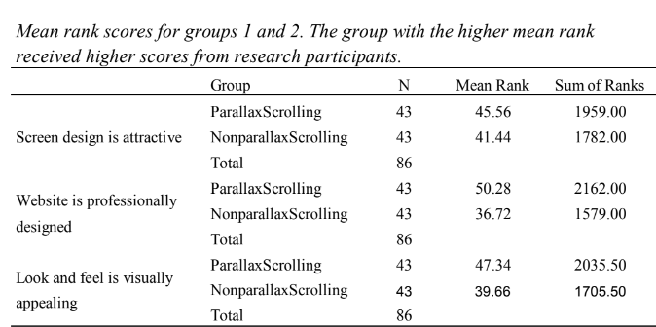

While participants differed significantly in their opinions of the professional design of the website, the questions directly related to the visual appeal of the website did not return any significant results. In essence the participants from both groups believed the website to be equally attractive and as a result hypothesis 5 was rejected.

- User experience and preference

Hypotheses 6 and 7 predicted that parallax scrolling would improve user experience and positively influence user preference. However, since a pleasurable user experience is dependant on website usability, enjoyment, fun, satisfaction, and visual appeal (Hassenzahl & Tractinsky, 2006; Norman, 2004), the other five hypothesis in this experiment would need to be true if these two hypotheses were to be supported, however four of those five hypotheses were rejected. Therefore hypothesis 6 and 7 were rejected. There was not sufficient evidence to show that parallax scrolling in a website will improve user experience and preference.

- Summary

The reliability of the results of a research project is dependent on the research framework. This chapter explains the overall design of this research project: hypothesis, variables, data analysis, instruments used, procedure, experimental set and the population sample. It gives the reader the opportunity to replicate the research if he/she so desires. It was hypothesized that parallax scrolling would improve user experience and influence user preference. However, the acceptance or rejection of these hypotheses depended on whether parallax scrolling improved perceived usability, enjoyment, fun, satisfaction, and visual appeal. These five variables have been claimed to directly affect overall user experience. With the exception of ‘fun’, the Mann-Whitney test failed to return any significant differences between the two experimental groups with respect to these variables. Therefore, the hypothesis that parallax scrolling improves user experience and preference was rejected.

